APPLICATION FORM
FOR INTERNATIONAL INDIVIDUALS

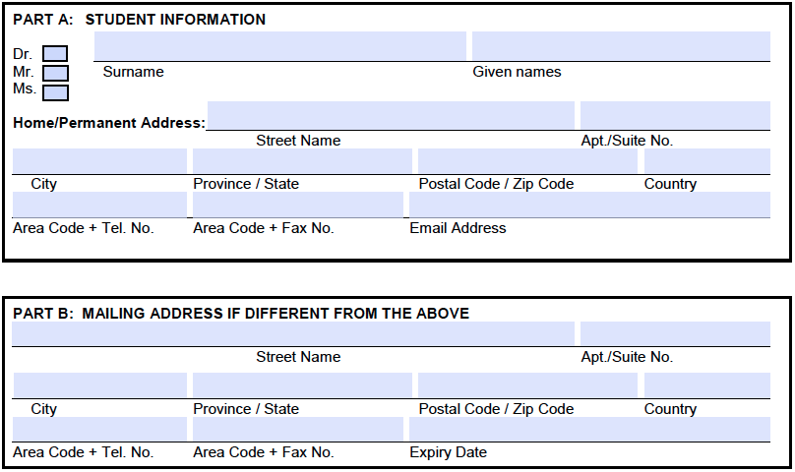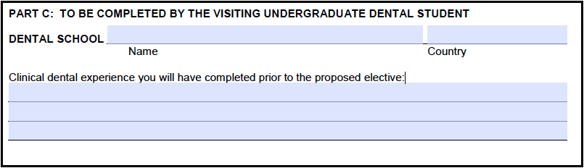

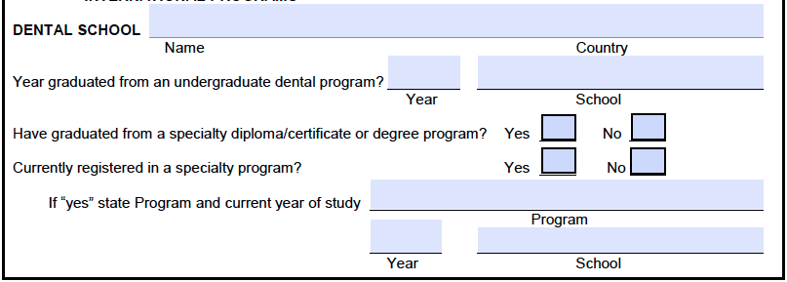

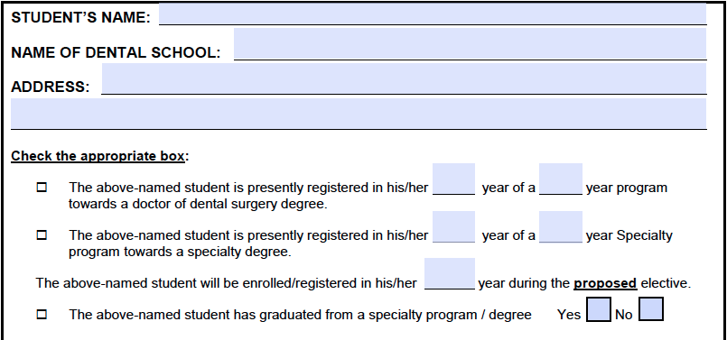

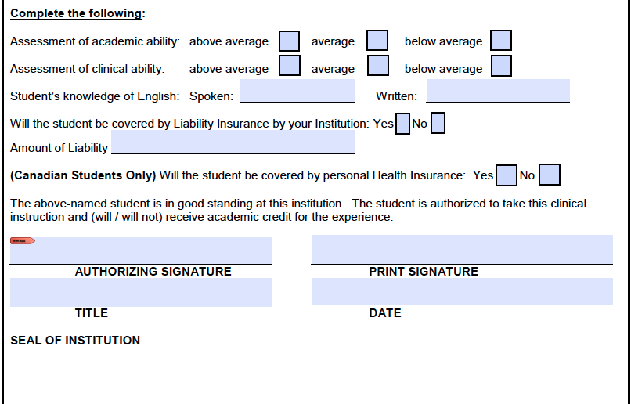

By my signature below,

- I certify that I have requested and am entering into this association without any promise or expectation of financial compensation or offer of employment or other appointment by BVUDentistry.
- I understand that all application material submitted to BVUDentistry becomes the property of BVUDentistry and is not returnable.
- I understand that the information submitted herein will be relied upon by BVUDentistry to determine my status for eligibility for this association. I authorize BVUDentistry to verify the information I have provided.
- I certify that the information in the application is complete and correct to the best of my knowledge and belief. I acknowledge the submission of any false information is grounds for rejection of my application or termination of my association with BVUDentistry.

INDIVIDUALS’S SIGNATURE DATE

